Chapter 11 - Answers

- Why does St. John the Baptist send his disciples with a question for Jesus?
  - St. John the Baptist wanted his disciples to follow Jesus. He continuously points to Jesus and tells everyone that Jesus will baptize with the Holy Spirit and with fire (see Mt 3:11). Sending his disciples to Jesus with a question is to help the disciples understand that Jesus is the Anointed One.
  - Further, not long after the Baptism of Jesus, St. John the Baptist was arrested and imprisoned until his execution. Knowing the scriptures, St. John would expect that Jesus would be healing the multitudes. Jesus tells the disciples of St. John to let St. John know that His ministry has begun and that all the prophets had spoken is coming to pass. In this way, St. John the Baptist would know that the incredible works of God were taking place and it would further show St. John the Baptist’s disciples Who Jesus really was.
- Who does Jesus quote in verses 1-10 and why? (Hint: two prophets).
  - Jesus quotes Isaiah and Malachi. Remember, St. Matthew is writing for a primarily Hebrew audience and is continuously connecting Jesus’ ministry to what was prophesied in the Scriptures (the Old Testament at the time of St. Matthew). This is yet another proof that Jesus is the Anointed One that the Israelites were awaiting.
- What is the meaning of verses 7-10, especially in light of Jesus repeating the question: “but what did you go out to see?”
  - His questions are both rhetorical and gravely serious. He’s asking the people to search their hearts and understand why they went to see St. John in the wilderness. Was it to see something novel? Or was it based on faith? Did you go to see a person that would imitate the leaders in Jerusalem? Or did you go to see an unfiltered, zealous, austere man who was unshaken in his ability to prepare people for the coming of the Christ? Jesus is really asking them, “what are you doing here listening to us? Are you here for a spectacle? Or are you here to have your sins forgiven and receive eternal life? Jesus ends this series of questions by saying that the prophets also spoke about St. John the Baptist – and St. John accomplished everything he was asked to do.
- I don’t like the explanation of verse 11 in the Orthodox Study Bible. What do you say? (In terms of the OT Law, John is the greatest prophet. But the New Covenant inaugurated by Christ is of such incomparable value that everyone who shares in it is, as it were, great than John. For by grace through faith under the New Covenant we become children of God and partakers of the Holy Spirit.)
  - Our Orthodox Tradition takes very seriously what Jesus says here. When the mother of Saints John and Iakovos comes to Jesus and asks for her sons to sit at Jesus’ right and left in the Kingdom (Mt 20:20), Jesus tells her those spots are already reserved. By Tradition, the Virgin Mary (to the right) and St. John the Baptist (to the left) take those positions. They are for the most important people on earth. Liturgically/iconographically, we see this on the iconostasion as the Mother of God and St. John the Baptist always take these positions relative to the icon of Christ. Therefore, I am not thrilled with the answer in the Orthodox Study Bible on this one.
- Why does Jesus bring up Elijah and who is this related to St. John the Baptist? (Here’s another hint: look at the icons of Elijah and St. John the Baptist)
  - Remember, Elijah did not suffer death. He was taken up into heaven on a chariot. Because of this, there was a pious thought amongst the Hebrews that when the Messiah was to come (the Anointed One/the Christ), Elijah would come back and walk the earth to usher in that era. Jesus is saying that St. John the Baptist is Elijah in that sense and that St. John the Baptist is ushering in the Messianic era through his preaching, teaching, and baptizing in the wilderness. Here are icons of Elijah and St. John. Notice how similar in appearance they are: rough clothing, unkept hair, austere appearances, the wilderness in the background, etc.
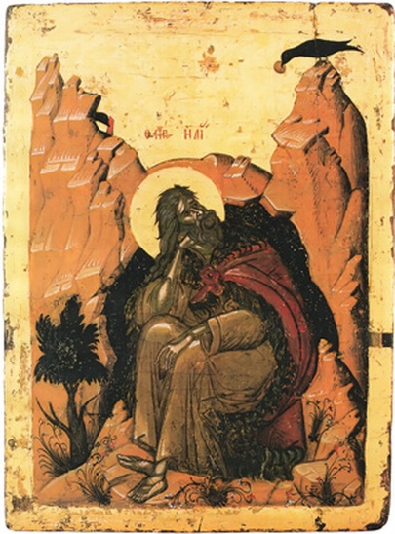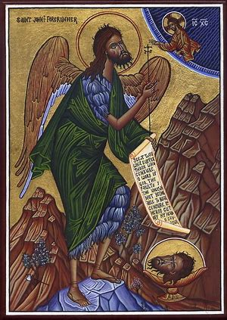
- What is Jesus saying in verses 16-19? What is this an indictment of?
  - Jesus is playing on a children’s game in which the children take up certain roles and the others respond. In this case, no one is taking up the roles and responding to what St. John the Baptist and the Son of Man (Jesus) have said!
  - This is an indictment of the Hebrew leadership in Jerusalem (the Pharisees (even Sadducees) and scribes) because they are never satisfied: St. John the Baptists is too strict and Jesus is too liberal. There is always a complaint for them to make because of their lack of faith and because of their unrighteousness.
- Why are the cities of Chorazin, Bethsaida, and Capernaum admonished and judged harshly? And why are Tyre and Sidon brought in as counter-examples?
  - The first set of cities are judged harshly because they have the Scriptures and traditions but lack faith and lack in a response to Jesus.
  - Tyre and Sidon, areas that are predominantly Gentile, will respond to the Word of God (Jesus). They bring to mind the Ninevites when Jonah preached to them. Much to Jonah’s surprise (and chagrin), these pagans immediately began to repent and accept God when Jonah preached. Similarly, when the Apostles go forth after Pentecost, these areas will become Christian as they accept the Word of God preached by the Apostles.
- How do verses 25-27 relate to the Gospel according to St. John?
  - There are remarkably similar to many verses in the Gospel according to St. John (see chapters 14-17). This is a instance in which Matthew relates the relationship between the Father and the Son as spoken by Jesus. Even though this is what St. John focuses on consistently, St. Matthew’s Gospel is not lacking in this information.
- What are the labors and heavy burdens Christ speaks of in verse 28? What is the yoke He speaks of in verse 29? What are your thoughts on these verses?
  - The labors and heavy burdens could by anything that affects us in our progress in the Faith. They could be outside influences that are difficult for us. They could be personal struggles with faith. They could be the responsibilities we have to others with regard to acting as righteously (not self-righteously) and faithful as possible as an example to them. They could be the responsibilities we have to others because of the gifts we have been given to help them. They could be many things.
  - The yoke refers us linking with and submitting to Jesus. Just as a yoke on oxen links them together and towards a concerted effort (pulling a plow in a straight line, for example), so we are to be yoked with Christ to walk the straight line of faith. Jesus is saying that His yoke, rather than being heavy and difficult to bear, is actually easy and light for those committed to Him.

